Chapter 11 Demo Requirements
Oct 28, 2026 · @Jim Kaufmann

Overview
Four small C# Windows Forms demos, one per Chapter 11 lab, show the same exception-handling ideas with a different problem. Each demo is built from the UML class diagram beside it.
Demo | Mirrors | What it shows
Demo1 FuelEconomy | Lab1 BMI | A static calculator, an enum, two custom exceptions derived from ArgumentException, catching FormatException
Demo2 TicketValidator | Lab2 OrderExceptions | Property setters and a constructor that throw custom exceptions; showing ex.Message
Demo3 LibraryCheckout | Lab3 LoginExceptions | A method that returns an object or throws one of three custom exceptions; a finally block
Demo4 DigitCipher | Lab4 DecoderRing | A class with Encode/Decode that throws a custom exception, and a setter that throws a built-in one
- Save the demos in /demos/Ch11/, named Demo1, Demo2, Demo3 and Demo4.
- Each demo uses the classes, fields and members exactly as shown in its UML diagram.
- Error messages appear in red on the form; normal results appear in black.

Demo1 FuelEconomy
A form that calculates a car's miles per gallon (MPG) and rates it.
Form: Miles text box, Gallons text box, Calculate button, result label.
- If Miles is not a number, display "INVALID MILES" in red. (Handle FormatException.)
- If Miles is less than 1 or more than 1000, display "INVALID MILES" in red.
- If Gallons is not a number, display "INVALID GALLONS" in red. (Handle FormatException.)
- If Gallons is less than 1 or more than 50, display "INVALID GALLONS" in red.
- If both are valid, display the MPG (one decimal place) and the rating: under 20 = Poor, 20 to under 30 = Average, 30 or more = Good.
- MpgCalculator.CalcMpg throws InvalidMilesException and InvalidGallonsException for out-of-range values.
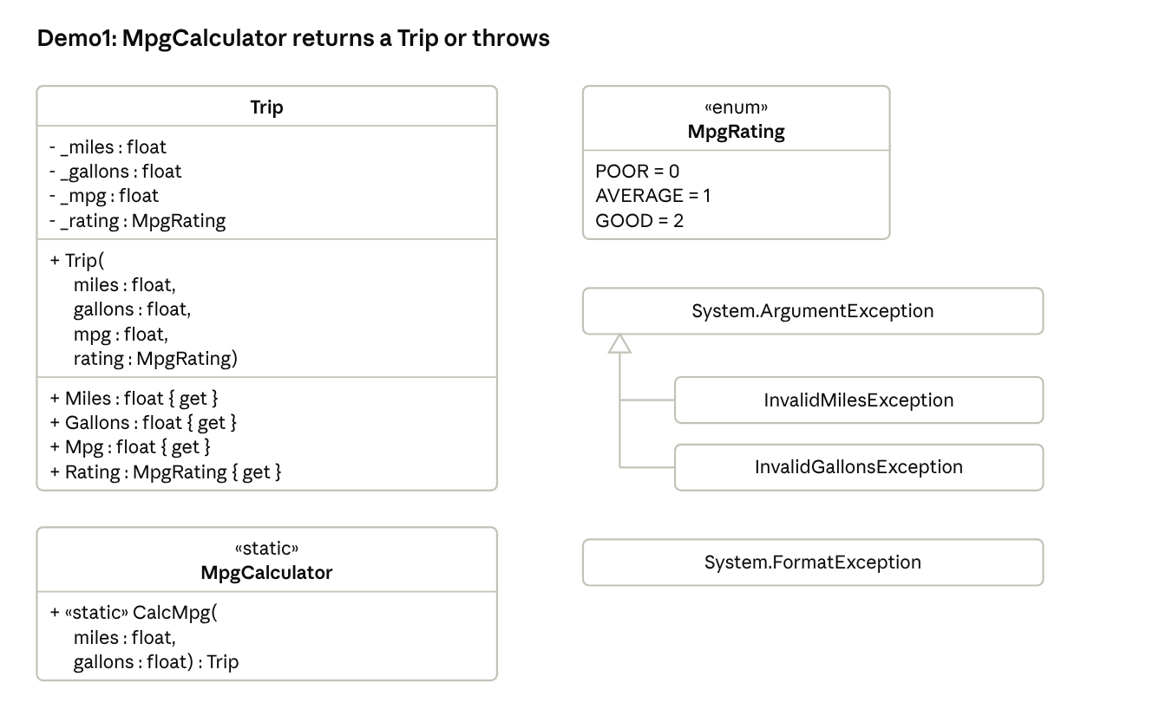
Demo1 FuelEconomy · UML class diagram

Demo2 TicketValidator
A form that checks that a theater ticket's row and seat are valid.
Form: Row text box, Seat text box, Validate button, result label.
- Row must be in the range [1, 20] inclusive.
- Seat must be in the range [1, 30] inclusive.
- If the constructor or a setter gets an invalid value, it throws InvalidRowException or InvalidSeatException with a message such as "Row must be between 1 and 20".
- The form displays the exception's Message in red.
- If Row or Seat is not a whole number, display "Row and seat must be whole numbers" in red. (Handle FormatException.)
- If both are valid, display "Ticket is valid".
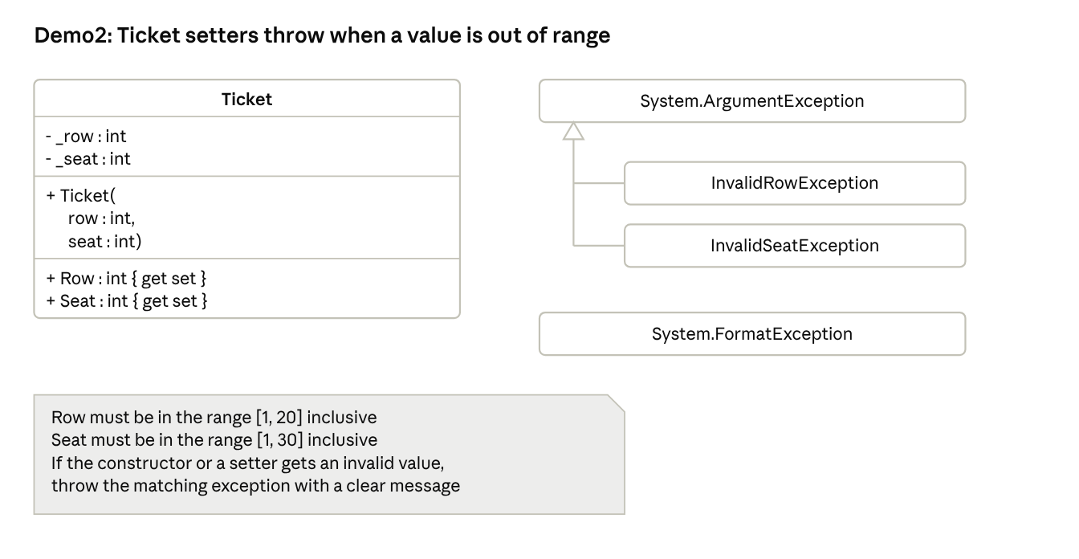
Demo2 TicketValidator · UML class diagram

Demo3 LibraryCheckout
A form that checks out a library book by its code.
Form: Book Code text box, Checkout button, result label.
- The form holds at least 3 books; at least one starts out checked out.
- Display "You must enter a book code" if the box is empty.
- Display "Book not found" if no book has that code.
- Display "Book is already checked out" if the book is checked out.
- Otherwise mark the book checked out and display "Enjoy" plus the title, for example "Enjoy Holes!".
- Checkout throws the three custom exceptions below; the form catches each one.
- A finally block clears the text box and puts the cursor back in it.
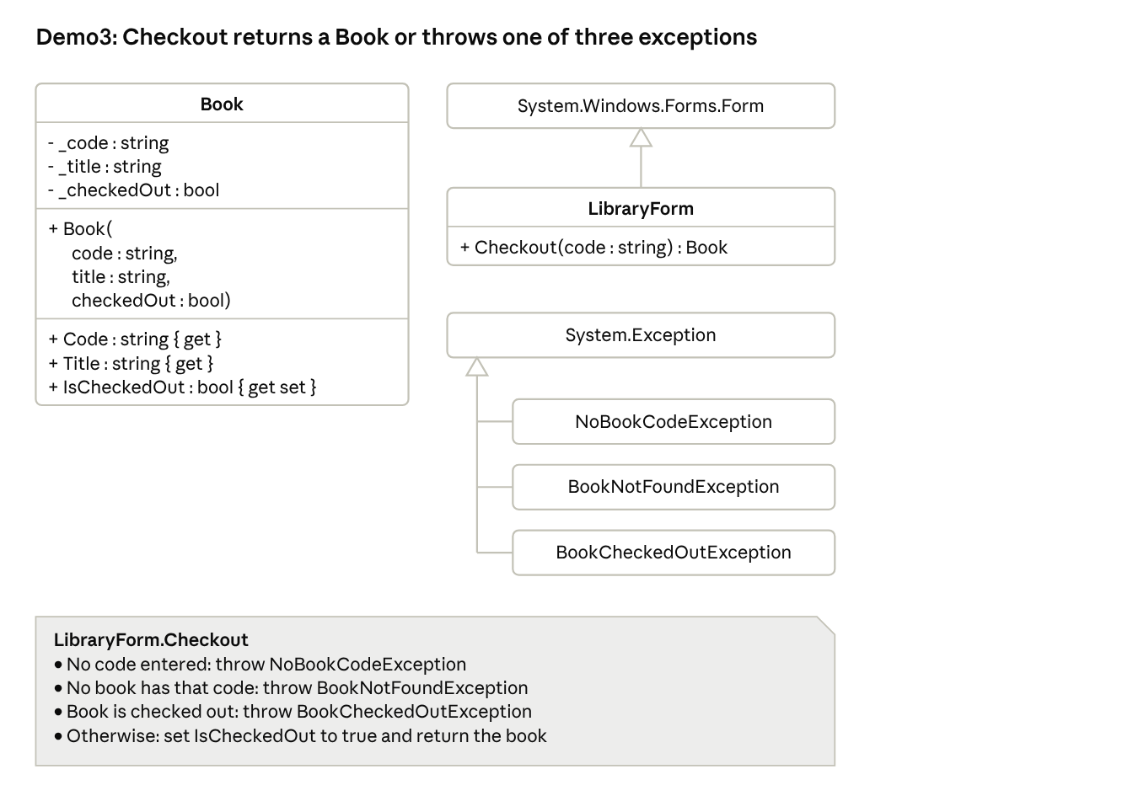
Demo3 LibraryCheckout · UML class diagram

Demo4 DigitCipher
A form that encodes and decodes number codes by shifting each digit by a key.
Form: Message text box with Encode button, Code text box with Decode button, Key text box, red error labels.
- Messages may contain only the digits 0–9.
- The key must be in the range [0, 9] inclusive.
- Encode: add the key to each digit, wrapping past 9 back to 0 (key 3: 2026 becomes 5359).
- Decode: subtract the key from each digit, wrapping below 0 back to 9 (key 3: 5359 becomes 2026).
- Encode and Decode throw InvalidCharacterException for any non-digit; display "Digits only" in red under that box.
- The Key setter throws ArgumentOutOfRangeException; display "Invalid key" in red under the key. A blank or non-number key shows the same message.
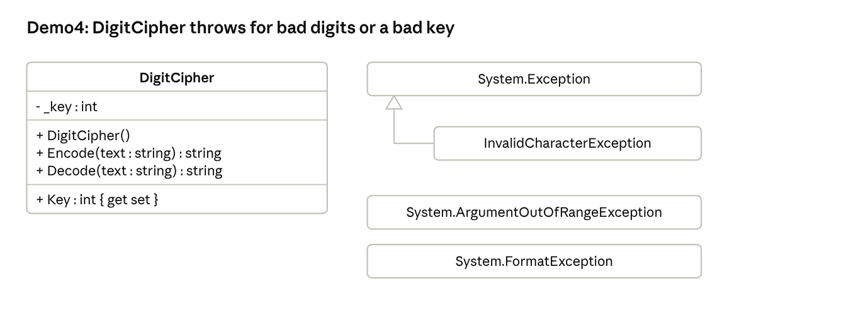
Demo4 DigitCipher · UML class diagram

Test cases
Run these inputs during the demo; each should produce the result shown.
Demo | Input | Expected result
1 | Miles 300, Gallons 10 | MPG: 30.0, Rating: GOOD
1 | Miles 250, Gallons 12 | MPG: 20.8, Rating: AVERAGE
1 | Miles 150, Gallons 10 | MPG: 15.0, Rating: POOR
1 | Miles abc, Gallons 10 | INVALID MILES (red)
1 | Miles 1500, Gallons 10 | INVALID MILES (red)
1 | Miles 300, Gallons 0 | INVALID GALLONS (red)
2 | Row 5, Seat 12 | Ticket is valid
2 | Row 0, Seat 12 | Row must be between 1 and 20 (red)
2 | Row 5, Seat 31 | Seat must be between 1 and 30 (red)
2 | Row A, Seat 12 | Row and seat must be whole numbers (red)
3 | (blank) | You must enter a book code (red)
3 | B999 | Book not found (red)
3 | B200 (starts checked out) | Book is already checked out (red)
3 | B100 | Enjoy Charlotte's Web!
3 | B100 again | Book is already checked out (red)
4 | Key 3, Encode 2026 | 5359
4 | Key 3, Decode 5359 | 2026
4 | Key 7, Encode 0911 | 7688
4 | Key 3, Encode 12a | Digits only (red)
4 | Key 10 | Invalid key (red)
Demo3 sample books: B100 Charlotte's Web, B200 Hatchet (checked out), B300 Holes.

